

User Guide

Warm Showers for Windows Phone

Version 1.3

October 5, 2015

Getting the App

Search for Warm Showers in the Windows Store or [follow this link](https://www.microsoft.com/en-us/store/apps/warm-showers/9nblggh0fms7).

Supported devices include Windows Phone 7.1, 8, 8.1, and Windows 10 Mobile.

Getting Help

If you have problems, questions, or feedback you can:

* Review and post questions to the [mobile forum on warmshowers.org](https://www.warmshowers.org/mobile)
* Add to the [issue queue](https://github.com/warmshowers/WarmShowers-Windows/issues) on GitHub
* Contact [klzig](https://www.warmshowers.org/users/klzig) through a Warm Showers message, or
* Contact him by sending email to [kurt@zighome.net](mailto:kurt@zighome.net)

Release history is [here](https://github.com/warmshowers/WarmShowers-Windows/blob/master/WarmShowers/WSWP7/Release%20History.md).

To contribute to Warm Showers for Windows development, see the [project page](https://github.com/warmshowers/WarmShowers-Windows/issues) on GitHub.

When seeking help, please provide the version number. It can be found on the about… page, accessed from the main menu.

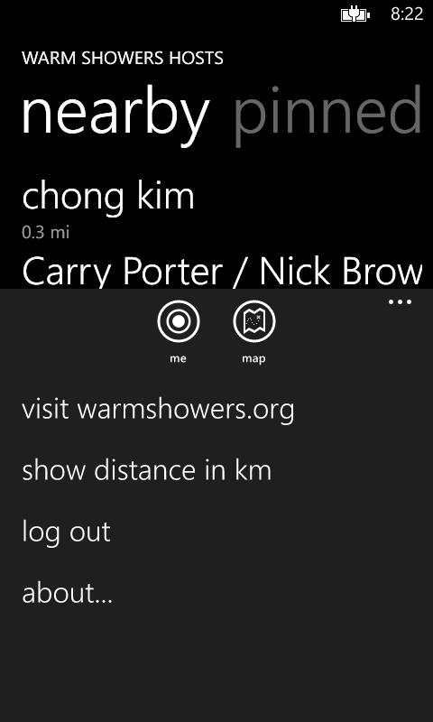

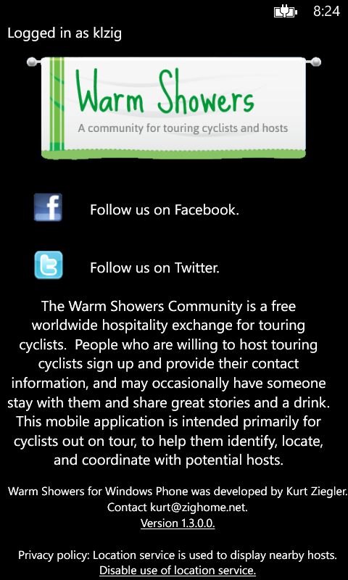

Rating the App

Please rate the app! On the phone, swipe left to show the list of installed apps. Press and hold Warm Showers to bring up menu. Press “rate and review.”

